Chapter 19, Solution 66.

Since we have two two-ports in series, it is better to convert the given y parameters to z parameters.

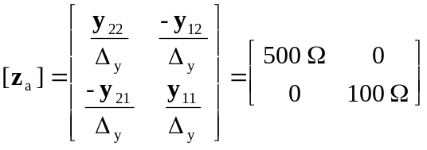

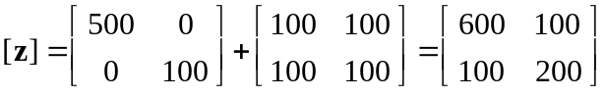

i.e. 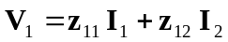
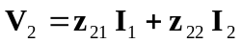

or 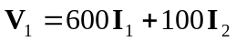 (1)
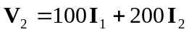 (2)

But, at the input port,
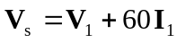 (3)

and at the output port,
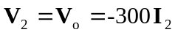 (4)

From (2) and (4),
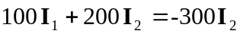
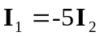 (5)

Substituting (1) and (5) into (3),
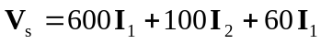
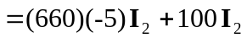
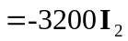 (6)

From (4) and (6),
